https://www.mp3tag.de/en/:

The universal tag editor (mp3tag.de)

The universal tag editor and more ...
Mp3tag is a powerful and easy-to-use tool to edit metadata of audio files.
It supports batch tag-editing of ID3v1, ID3v2.3, ID3v2.4, iTunes MP4, WMA, Vorbis Comments and APE Tags for multiple files at once covering a variety of audio formats.
Furthermore, it supports online database lookups from, e.g., Discogs, MusicBrainz or freedb, allowing you to automatically gather proper tags and download cover art for your music library.
You can rename files based on the tag information, replace characters or words in tags and filenames, import/export tag information, create playlists and more.
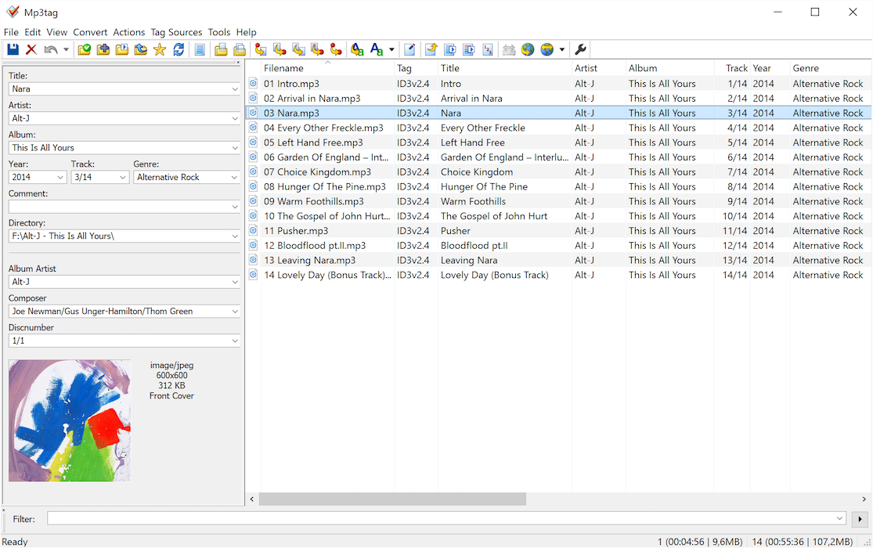

Main features:
Batch Tag Editing Write ID3v1.1, ID3v2.3, ID3v2.4, MP4, WMA, APEv2 Tags and Vorbis Comments to multiple files at once.
Support for Cover Art Download and add album covers to your files and make your library even more shiny.
Import from Discogs, freedb, MusicBrainz Save typing and import tags from online databases like Discogs, freedb, MusicBrainz, and more.
Replace characters or words Replace strings in tags and filenames (with support for Regular Expressions).
Create Playlists automatically Create and manage playlists automatically while editing.
Rename files from tags Rename files based on the tag information and import tags from filenames.
Export to HTML, RTF, CSV Generate nice reports and lists of your collection based on user-defined templates.
Full Unicode Support User-interface and tagging are fully Unicode compliant.
Besides these main features Mp3tag offers a variety of other functions and features ranging from batch export of embedded album covers, over support for iTunes-specific tags like media type or TV Show settings, to combining multiple actions into groups that can be applied with a single mouse click.

Supported Audio Formats
Advanced Audio Coding (aac)
Apple Lossless Audio Codec (alac)
Audio Interchange File Format (aif / aifc / aiff)
Direct Stream Digital Audio (dsf)
Free Lossless Audio Codec (flac)
Matroska (mka / mkv)
Monkey's Audio (ape)
Mpeg Layer 3 (mp3)
MPEG-4 (mp4 / m4a / m4b / m4v / iTunes)
Musepack (mpc)
Ogg Vorbis (ogg)
IETF Opus (opus)
OptimFROG (ofr / ofs)
Speex (spx)
Tom's Audio Kompressor (tak)
True Audio (tta)
Windows Media Audio (wma)
WavPack (wv)
WAV (wav)

